**Day 1 – Sample Exercises (01-02-2021)**

1) Collect the following basic information about your machine using the /proc file system and answer the following questions:

1. How many CPU and cores does the machine have?
2. 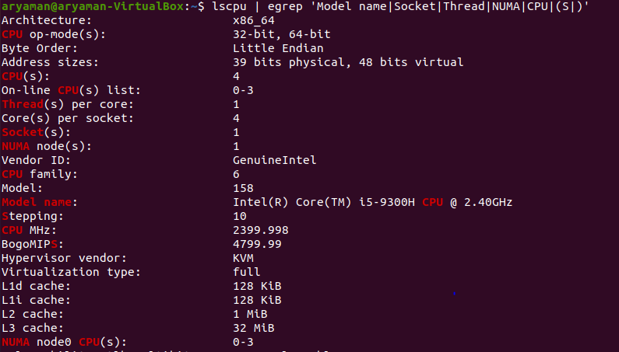
3. What is the frequency of each CPU ?
4. 
5. 

c. How much memory does your system have?



d. How much of it is free and available? What is the difference between them?

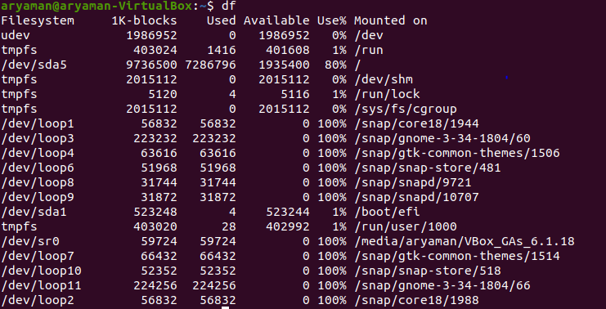 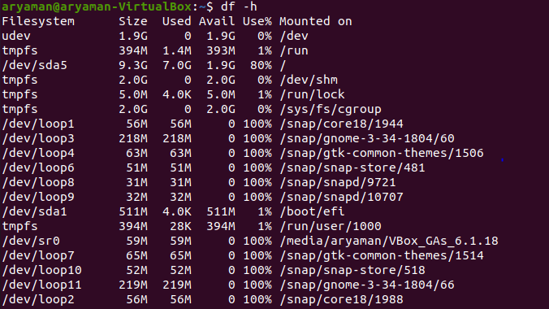 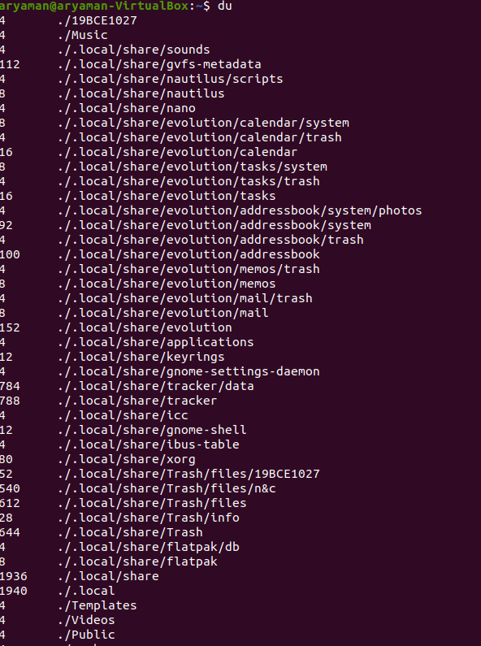 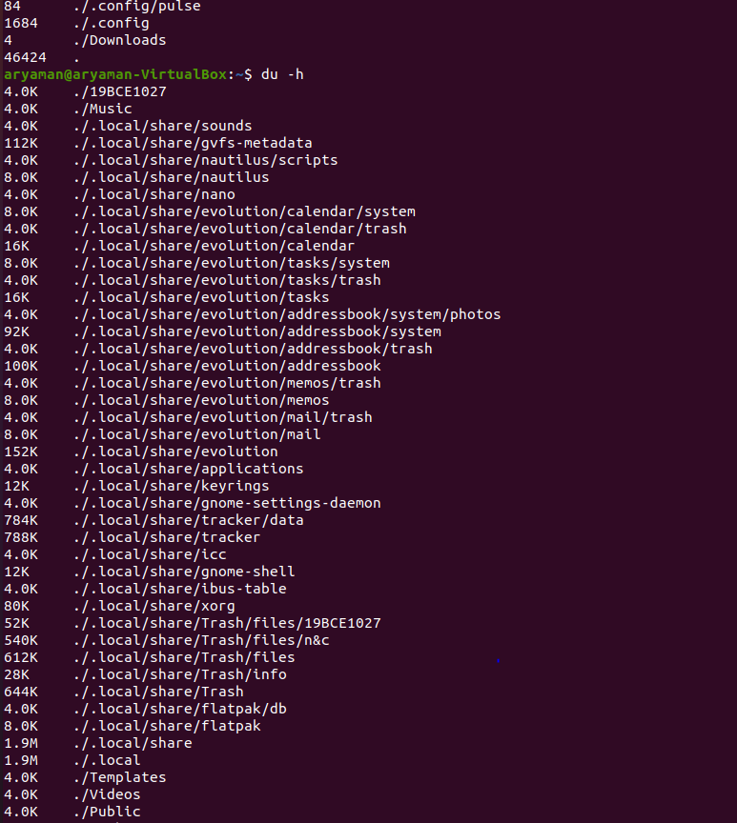 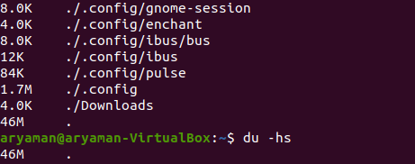 **Free memory** is the amount of **memory** which is currently not used for anything. This number should be small, because **memory** which is not used is simply wasted. **Available memory** is the amount of **memory** which is **available** for allocation to a new process or to existing processes.

1. What is total number of user-level processes in the system?
2. 

f. How many context switches has the system performed since bootup?

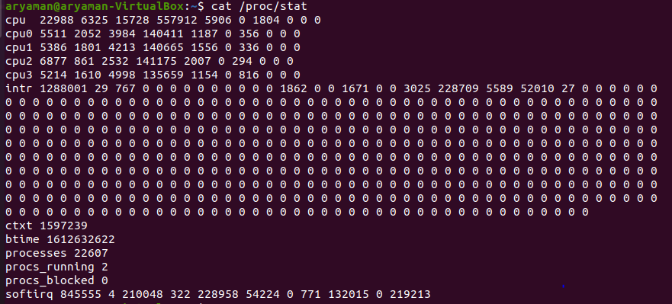

2) A pastry chef bakes 10 cakes as a stock for a bakery shop. In a random manner he visits the bakery to check how many are left. Whenever the count is less than 10, he bakes more to make the total 10. Customer can buy cake whenever there is any cake in stock otherwise, he has to wait. Find out at any instance how many cakes are available?